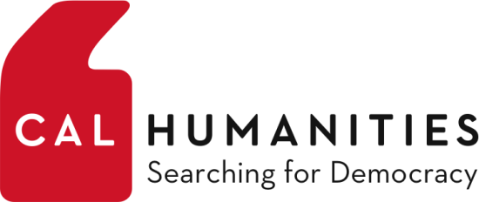
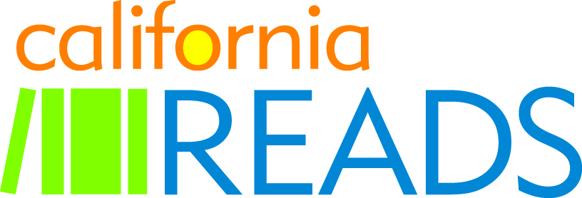

CALIFORNIA READS
Self-Evaluation Questions
With the California Reads program, Cal Humanities hoped to:

- Stimulate thoughtful conversations about democracy through library-initiated, community-wide programs using the California Reads booklist as a springboard.

- Inspire community members of all ages to meaningfully engage with one another and in civic life.

- Support libraries with grants and content resources to serve a broad cross-section of their community and to help build the possibility for fruitful partnerships.

- Build the capacity of libraries to be hubs of civic engagement for their communities and increase the value that communities have for their libraries.

Please use this section to tell us how successfully we were able to support you in these endeavors. Your responses are for internal institutional learning only, so please be as candid as possible. Enter your responses below each question and add space as needed. Save this file as a Word document or PDF and upload with your online final report form.

- Describe in a sentence or two each of the programs you offered as part of CA Reads.
- How successful were your programs generally at stimulating thoughtful community conversations and interactions?
Very successful
Somewhat successful
Neutral
Somewhat unsuccessful
Very unsuccessful

Please give an example or two that illustrates what happened in this regard. What were your
biggest successes? What were your biggest challenges?

- What kind of audiences did you reach with your activities? Which, if any, were new or unexpected?

- Did your project include partnerships with community members and/or organizations? If so, with whom and for what purpose (for example, reaching audiences, program content, etc.)? Which, if any, were new partnerships? Which would you continue?
- Do you think you had any civic outcomes from your project activities? If so, what were they (for example, did decision/policy makers come to events, did participants become engaged in civic issues, etc.)?
- Do you think your library jurisdiction was strengthened in any way by this program? If so, in what ways (for example, new acquisitions, new programming resources, new audiences, staff development, community support/respect, etc.)?
- How would you generally rate the support you received from Cal Humanities?
Excellent
Very good
Good
Fair
Poor

What did you appreciate most? What could have been better?

- Cal Humanities’ partner in designing and implementing California Reads is the California Center for the Book. Did you have contact with CCFB during the program? If so, how would you rate the support you received?
Excellent
Very Good
Good
Fair
Poor

What did you appreciate most? What could have been better?
- What were the best features of CA Reads from your point of view? What should we do differently in the future?

